**ASSIGNMENT : LAB 03**

**SUBJECT : Object Oriented Programming**

**ROLL NO : 24BSAI29**

**SUBMITTED BY : Syed Muhammad Qasim**

**SUBMITTED TO : Ms. Mehwish shaikh**

Mehran University of Engineering and Technology Jamshoro

**Task#01**

Write a calculator program in java by taking values from user.

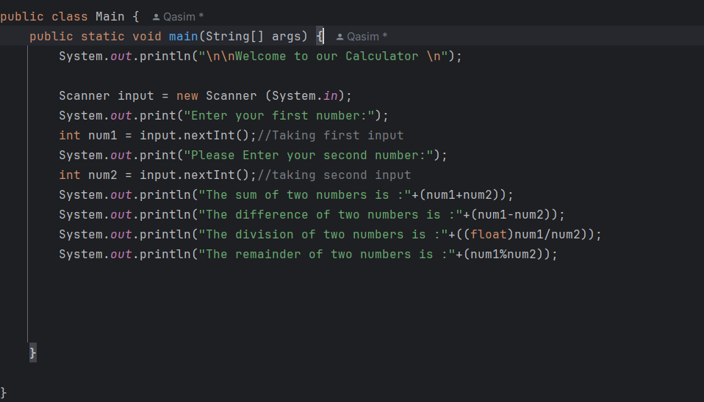

**OUTPUT:**

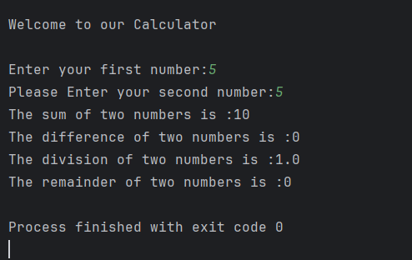

**Task#02**

Imagine you are developing a **basic salary management system** for a company. Implement a Java program that performs the following tasks using different types of **operators**:

1. **Salary Calculation (Arithmetic Operators)**:
   * A company pays a fixed **base salary** of **50,000**.
   * Each employee gets a **bonus of 7,500**.
   * Calculate the **total salary** using an arithmetic operator and print the result.
2. **Performance Evaluation (Relational & Logical Operators)**:
   * An employee's performance score is **85**, and the passing score is **75**.
   * Check if the employee qualifies for a **promotion** using a relational operator.
   * The company promotes employees who **pass the performance test (score > 75) AND have completed at least 2 years of service**.
   * Use logical operators to check if the employee qualifies and print the result.
3. **Tax Deduction (Assignment and Arithmetic Operators)**:
   * The company deducts **10% tax** from an employee’s salary.
   * Calculate and update the salary after tax deduction using the **\*=** operator.
   * Print the final salary after tax deduction.
4. **Increment & Decrement in Leave Balance**:
   * An employee starts with **10 paid leaves**.
   * Each time they take a leave, decrease the count using the **decrement operator**.
   * If they work extra, they gain an additional leave using the **increment operator**.
   * Simulate both scenarios and print the updated leave balance.

**Instructions:** Implement all operations correctly, print meaningful messages for each step, and ensure proper use of operators.

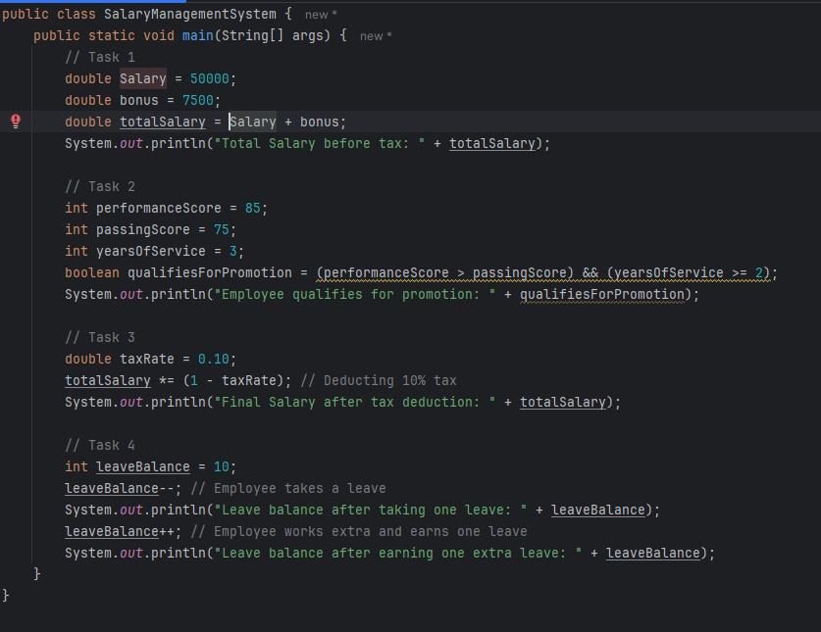

**OUTPUT:**

